Найменование учреждения: ГУ СОШ №5
ФИО: Авазова Зарина Файдрахмановна
Должность: Учитель английского языка
Стаж работы: 7 лет
Категория: 2
Предмет: английский язык
Тема: Memory
Класс: 10
Цели: образовательная - ученик закрепляет и использует лексический и грамматический материал (знания) по темам «Привычки», «Память», «Сохранение здоровья, стресс»;
Воспитательная - воспитывает в себе чувства уважения к другим культурам и традиционной пище других народов, правильное отношение к своему здоровью;
Развивающая – ученик развивает монологическую, диалогическую речь, навыки письменной речи, память.
Оборудование: интерактивная доска, карточки
Тип урока: закрепление
Формы работы: работа в паре, работа в группе, индивидуальная работа.
План
  - Орг. Момент
Relax-minute: Raise your right hand to the Sun, left-to the Earth. Now Take the energy from Sun, Earth, and now connect your hands with your classmates, give that energy to them.
  - Основная часть
- picture-memory
- missing letters
- guess
- combination of words
- listening
- ВИЗ
- Eating habit
III. Подведение итогов
1. рефлексия
2. оценивание

Ход урока
- Picture-memory
I’ll show you a picture and you should remember the pictures and number under it.

- Missing letters Слайд №2
Libra [li:brә]-Таразы
Capricorn [kаеpriko:n]- Тауешкі
Aries [ eәrie:s]-Тоқты
Sagittarius [saidзiteәriәs]-Мерген
Gemini [dзeminai]-Егіздер
Aquarius [әkweәriәs]-Суқұйғыш
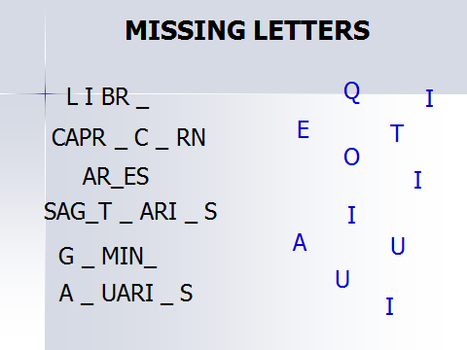
- Guess. I’ll give a shit of paper and you should show this word (meaning of the word) without words with mimic (facial expressions) and gesticulation: anger, disgust, fear, happiness, sadness, surprise.

- Combination of words
Improve brain
Solve puzzles
Keeping fit
Lose temper
Pay attention
Waste time
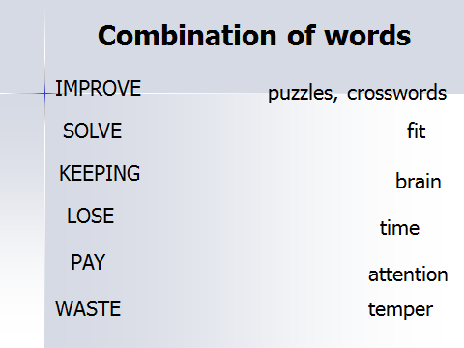
5. Listening. Text: “Safari Parks”
Safari Parks
A safari park is like large zoo, where the animals live in natural conditions. There are several safari parks in Britain and they are very popular places for visit. One of the most famous is at Windsor, which is close to London airport.
You can visit some parts of the safari park on foot. Here you can see the animals that are not dangerous, like giraffes, zebras, camels and antelopes. The animals walk around as if they were in Africa.
But safari parks also have lions, tigers, leopards and other dangerous animals. These cannot be kept with the other animals, because they would eat them. They would also eat the visitors, so they have to drive through the parts where these animals live. You have to keep your windows closed and you must not get out of the car. It is not a good idea to take a new car into this part of the park, because the monkeys climb on the cars. They often scratch the paint and they sometimes pull aerials and windscreen wipers off.
Safari parks are much better than ordinary zoos, because the animals do not have to live in small cages.

True/false
      - A safari park is like small zoo, where the animals live in natural conditions.
      - You can visit some parts of the safari park on foot.
      - Safari parks are much better than ordinary zoos, because the animals live in small cages.
      - The animals walk around as if they were in America.
      - One of the most famous safari park is at Windsor.
      - It is not a good idea to take a new car into this part of the park, because the monkeys climb on the cars.
      - Here you can not see the animals that are not dangerous, like giraffes, zebras, camels and antelopes.

- ВИЗ-1
Gerund
- I didn’t answer the phone call because I carried on (write).
- My friend dislike the idea of (spend) holidays at home.
- Omar is interested in (learn) French.
- She advised (change) my style.
- There is not possibility of (buy) the house.
- the room is need (clean).

Word building
powerful
continuation
decision
act

ВИЗ-2
Participle: join 2 sentences
- The woman was sitting on the bench. She was reading the book.
- Omar was watching TV. He was talking with friend.
- Asel was doing shopping. She found the money.

Word building
intelligent
harm
use
breathless

ВИЗ-3
Infinitive
- Omar forgot (ring) me.
- Did you remember (pick up) the photos today?
- I’m sure I didn’t forget (lock) the door.
- We regret (inform) you that we lost your dog.
- Asel tried (open) the door, but she couldn’
Word building
responsible
addiction
forget
improvement

- Eating habits: find words which belong to this theme: unpleasant, delicacy, urchin, seaweed, disgusting, snail, eel, octopus, and squid.
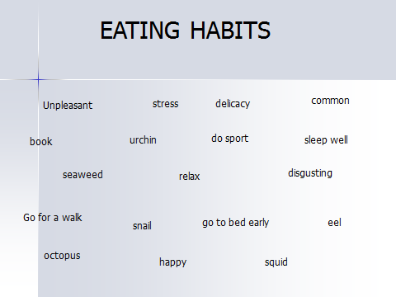

III. Подведение итогов
1. Каждому ученику дается время -2-3мин для самооценки и рефлексии.
2. Д/з: написать эссе на тему «Память».

