Good luck!

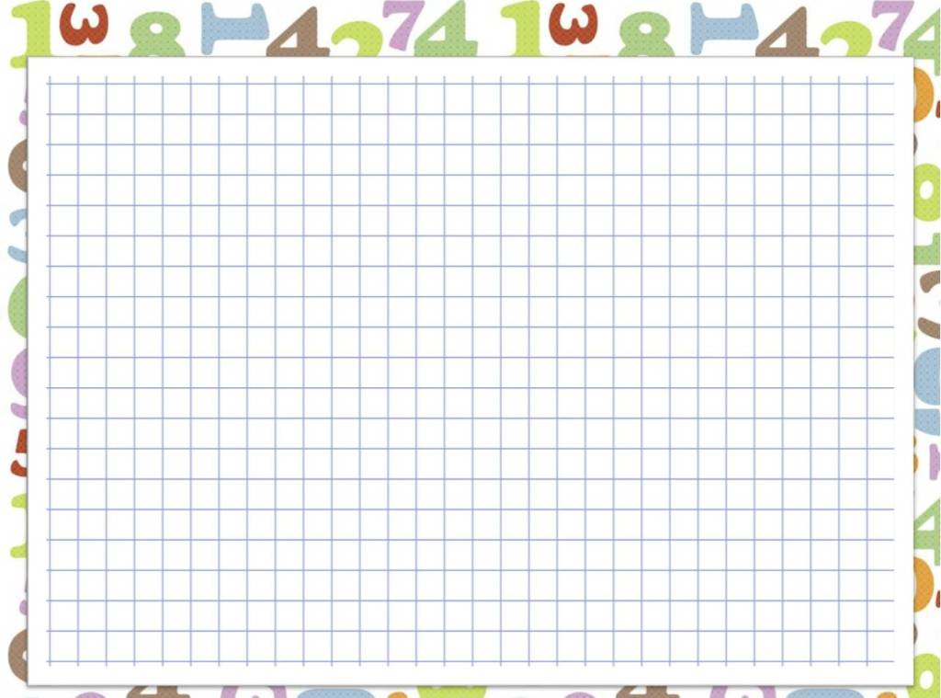

I Write the numbers:
1) thirty-two
2) seventy
3) eight
4) six hundred and eleven
5) one hundred and ninety

II Write the numbers in words:

a) 23
b) 17
c) 4
d) 59
e) 391

III Translate the sentences:

1) There are eight hundred students in our school.
2) There are fifty states in America.
3) My father is thirty-five years old.

