Exercise 1. Open the brackets using Present Perfect tense
- She (translate) the text, (make) up a dialogue and (write) three exercises.
- What a wonderful picture you (paint)!
- He (design) a new clothes collection. It is wonderful!
- I (buy) a packet of orange juice and a cake.
- She (sell) all the apples.
- He (make) a delicious soup.
- I (collect) a lot of stamps.
- The man (fix) the broken car.
- He (finish) a new story.
- Children, you (do) your home task?
- She (type) three documents and (post) some letters.
Exercise 2. Match the sentences (the result of the action)
- I have just had lunch. | A) He is not here.
- She has already left the house. | B) I am not hungry.
- Somebody has broken the window in our classroom. | C) It’s too cold in here.
- I have known her since our childhood. | D) He knows this country very well.
- We have left all the money at home. | E) She can not write now.
- Your mistakes have taught you nothing. | F) She must be on her way to college.
- She has cut her finger. | G) She is my best friend.
- He hasn’t come yet. | H) We can’t buy anything.
- David has been to the USA more than once. | I) It is open now.
- Some fool has left the door unlocked. | J) You are doing the same silly thing again.
- Grandmother has written a letter. | K) She is going to the post-office now.
- The boy has fallen ill. | L) His mother is very upset.

Picture 1. Say who has broken which park rule.
LUNCH IN THE PARK.
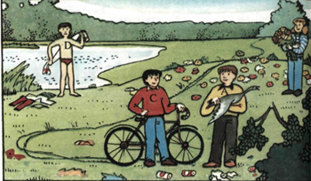
You should not break branches, pick flowers, catch ducks, leave litter, swim in the lake, ride bikes in the park.

