Australia we havent known
Objectives:
1. to revise the material on the topic;
to develop students’ intellectual abilities according to the topic;
2. to develop skills in reading, listening, writing;
to teach students to express their opinion;
to develop students’ skills and habits of prepared and unprepared speech (individually, in pairs and groups);
3. to teach to respect traditions, customs and to understand the culture of other countries.
Equipment:
The cassette player, copies of the text materials to give out, pictures of the views of Australia, playfields and dice for games, material for application, placards for the word power game, language support, proverbs, sheets of paper to make up sentences, Balmont’s portrait and his poem about Australia, Australian dollars for game, magnets.
The plot
1. Greetings. Introduction to the lesson.
Good morning, dear friends! I am very glad to see you. Today we are going to make a very enjoyable trip to a wonderful country situated on a green continent.
What country is it? (Ученики отвечают на вопрос, приводят факты и аргументы.)
The aim of our lesson is to read, listen, find out and tell about Australia.
Why have we chosen this topic to discuss? (Учащиеся отвечают на вопрос.)
2.Warming up.
Do you want to go there? I would like to know if you are ready for traveling. I have prepared some questions for you. Use language support! Приложение 1
Ученики дают полные ответы на следующие вопросы учителя:
Do you like traveling?
What way do you like traveling?
What does traveling give you?
Is it useful? Why?
Have you ever been to Australia?
What is Australia rich in?
What is the main industry in Australia?
3. Phonetic drill
Look at the blackboard! You see some proper names, you need to read them correctly.
Australia – Australian; Sydney – Sydneysiders; Melbourne – Brisbane;
Indian – Pacific; Murrey – Darling; Equator – hemisphere; Botany Bay – Coral Sea; Great Barrier Reef.
4. Practice
a) Word power game (на доске плакат по теме «Путешествие»)
Look at this placard! Let’s see how many words you know. (Ученики называют слова, относящиеся к теме «Путешествие»)
b) I invite you to play a game «Tell us about Australia».
You see fields for a game and dice for everybody. I am the first to begin. You are the next. (Учащиеся составляют различного рода предложения с «выпавшим» словом. Если выпадает знак вопроса, то составляется вопросительное предложение по теме).
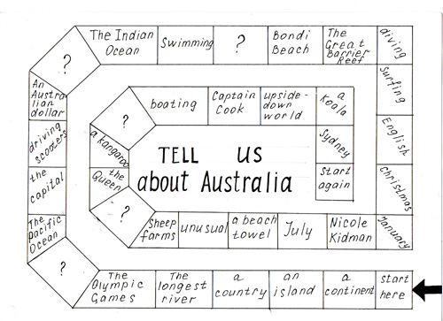
5. Reading
a) I want to read some information for you. Listen to it and say what countries are described. Why do you think so? Приложение 2
b) It is your turn to read. Read and say what is true and what is false. Why? Приложение 3
c) Do you like reading Russian poems? I’d like Olga to recite one of them.
Ученица читает наизусть стихотворение Константина Бальмонта. Приложение 4
d) Do you like this poem? Who is its author? I want you to read Balmont’s biography and to say what you have known about him. Приложение 5
6. Listening
a) Listen to the cassette player! The task is to understand who else has ever been to Australia. Write down the information into the table! Приложение 6
7. Relaxing
а) Let’s play a game! It’s called «Jeopardy».
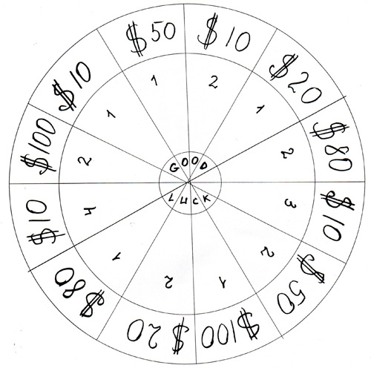
If you want to visit Australia you need much money. What is Australian money? (Ученики отвечают на вопрос.)
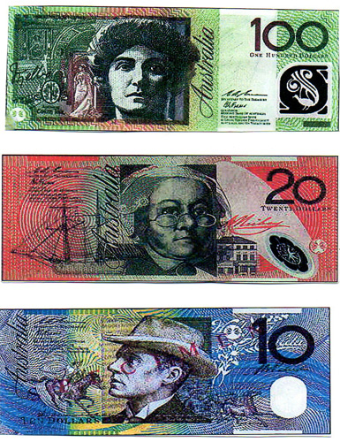
Choose the number of the questions. If you want to answer an easy question, choose a $10 or $20 one. The $50 and $80 questions are more difficult. The most difficult ones cost $100.
Begin so, - “I choose the question number 1 which costs $10”.
Let’s try to earn money! Приложение 7
b) How many dollars have you earned? (Ученики подсчитывают количество заработанных долларов, озвучивают сумму.) You are rich now. You have an opportunity to go to Australia where it is autumn now. It’s unusual for us. What unusual things do you know else? (Ученики отвечают на вопрос.)
8. Reading «Christmas in Australia» Приложение 8
(Задания: Answer the questions; Right or wrong; Define the tenses; Discuss; Tell what you have known about Australia).
9. Making up sentences Приложение 9
There are words on sheets of paper (предварительно разрезать таблицу на квадраты). Take them and make up sentences about Australia and Australians.
10. An oral essay
You have read different guides, encyclopedias, magazines, newspapers and I want to listen to your speech. Would you like to live in Australia? Why? Why not?
11. Pair work (Одна - две пары учащихся раскрывают тему эссе в диалоге.)
12. Summing up
a) Let’s make an application!
What is Australia for everybody of us? Use language support! Приложение 1
I’m the first. I believe Australia is a green continent because there is much greenery.
б) We have made a flower! The flower is unusual like Australia itself.
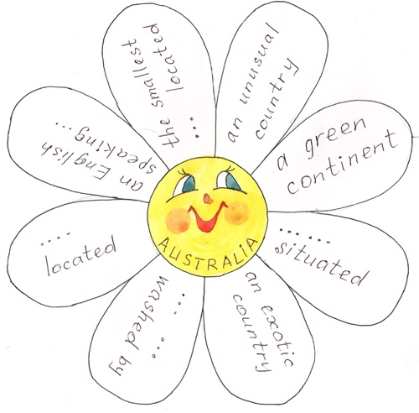
13. Marks
I thank you for your excellent work and give only good marks. The lesson is over, good bye!

