Amazing Nature
Animal senses
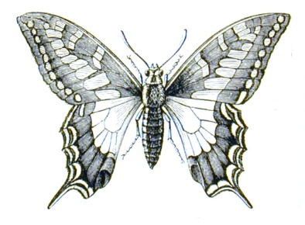
Humans have five senses; sight, hearing, taste, smell, and touch. We use these senses every day of our lives when we work, play, eat, drink. Animals have sense too, and sometimes they are much more powerful than ours. We have our food prepared for us
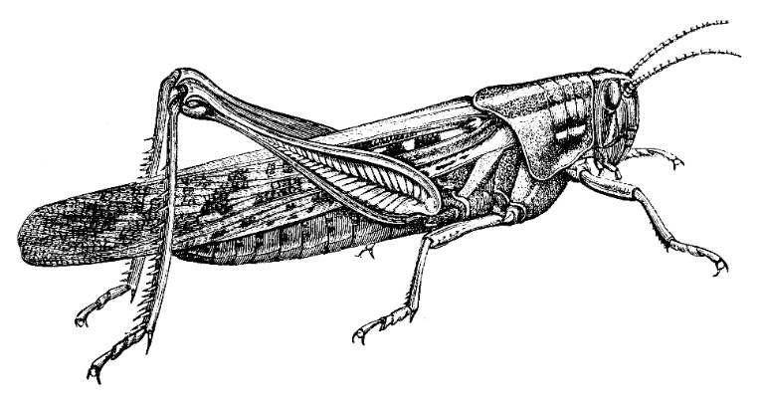
But animals need to find their own food using their senses. For example, predators often have very good sight. Some birds of prey can see a mouse at a distance of 1.5 kilometers. However, they don’t always catch the mouse. Mice have amazingly good hearing and this helps them escape from predators!
Insects sometimes have senses that are different from ours. For example, butterflies don’t taste with their mouths – they taste with their feet. Crickets don’t hear with their ears – they hear with their legs. Chameleons have two eyes, the same as we do, but they can move their eyes separately and look in two different directions at the same time! Some animals seem to have special sense that tells them about the future. Birds, ants and many other animals look for food more busily just before bad weather. This helps them survive because it’s more difficult to find food when the weather is bad. They know that bad weather is coming. Birds also use this ability to avoid bad weather when they fly long distances. For centuries, people have noticed that animals often behave strangely before an earthquake. For example, in January 1975, a lot of farmers in one part of China told scientists that their horses and cattle did not want to go inside the barns. A few days later, there was a large earthquake in that region. Do animals have a special sense that predicts earthquakes? The answer is probably yes, but scientists do not yet understand how it works.

Answer the following questions

- How many senses do humans have?
____________________________________________________

- What do animals use to find their food?
____________________________________________________

- Which sense do birds of prey use to catch their food?
___________________________________________________

- Which sense helps mice to escape from predators?
___________________________________________________

- What do butterflies use to taste?
____________________________________________________

- What do crickets use to hear?
___________________________________________________

- What is special about chameleons?
___________________________________________________

- Which animals look for food more busily before bad weather?
___________________________________________________

- When do they behave strangely?
___________________________________________________

- What did farmers tell scientists in China?
__________________________________________________

