Teacher: Nurmakhanova Zhanar Myrzabekovna Date: 20.10.2014
Form: 10 B
Theme: “Travelling (revision)”
Objectives:
1. Forming and revising their knowledge about famous explorers.
2. Developing pupils` speaking, reading and communicative skills.
3. Maximize pupils` potential and widen their world outlook.
Equipment: an active board, handouts.
Plan:
- Greeting. Reporting the objectives of the lesson. Small talk.
- Speaking (the quote)
- Review of vocabulary
A. Matching the words and their definitions
B. Filling the blanks
C. Matching the photos with the explorers
D. Filling in the table about the explorers (names, nationalities, lifespan, voyages).
- Reciting a poem about Columbus.
- Guessing a puzzle.
- Reading the text about Columbus and Columbus Day.
- Retelling the text in the snowball way.
- Speaking
- Doing a test on the text “Columbus Day”.
- Self-evaluation of the test.
- Conclusion
Outline:

- Greetings. (1’)
Good afternoon pupils, colleagues and our guests.
Teacher: Today the theme of our lesson is ““Travelling (revision)”
- Warm-up (1’)
Speaking. (1’)
Look at the quote of the famous explorer David Livingstone:
I`ll go anywhere as long as it`s forward”
How can you understand it? Pupils give their opinions.
- Review of vocabulary (3’)
Now we should revise some words which we can use in our discussion, you have stripes with six words and their definitions, your task is to match them. Work in pairs.
Matching:
- Explore (v) –travel across an area in order to learn it.
- Explorer (n) – someone who travels around the place that other people don`t know much about.
- Route (n) - a road or a path that you use when you go from one place to another.
- Voyage (n) –a long journey especially on a ship.
- Discovery (n) –the fact of finding or learning about something that was hidden or unknown.
- Discover (v) –find something that was unknown before.
Let`s check, if you are right raise your hands.
Filling the blanks: (1’)
On your desks there are handouts, look at the first exercise, you have to fill in the blanks, using these words.
- The first travelers were explorers who went on trips to find wealth, fame or something else.
- He made some voyages to the New World.
- James Hudson was a naturalist and he wanted to discover and to explore new plants and animals.
- The Silk Road was an important route to China.
- The discovery of America changed the history and the geography of the world
Matching: (1’)
Teacher: I want you to look at the pictures of some famous European explorers, do you know who they are?
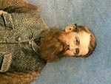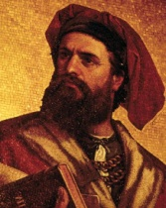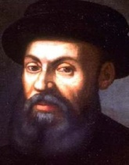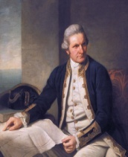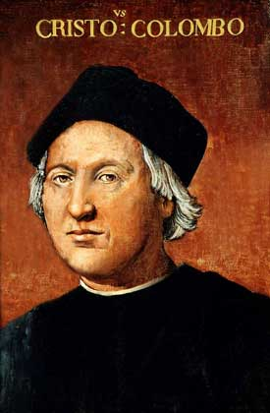

Marco Polo James Cook C Columbus Magellan John Speke
The task is done in mini-groups.
Teacher: Let’s check up.
I have prepared a table about famous travelers. (1’)

NAMES OF FAMOUS EXPLORERS | THEIR NATIONALTITIES | THEIR LIFESPAN | FAMOUS VOYAGES OF EXPLORATION
MARCO POLO
CHRISTOPHER COLUMBUS
FERDINAND MAGELLAN
JAMES COOK
JOHN SPEKE
Teacher: Now I want to talk about the great explorer. It is Christopher Columbus. You will listen to the poem, read the text.
- Reciting a poem (5’). Listening to pupils’ reciting.
In fourteen hundred ninety-two
Columbus sailed the ocean blue.
He had three ships and left from Spain;
He sailed through sunshine, wind and rain.
He sailed by night; he sailed by day
He used the stars to find his way.
A compass also helped him know
How to find the way to go.
Ninety sailors were on board;
Some men were worked while others snored.
Then the workers went to sleep;
And others watched the ocean deep.
Day after day they looked for land;
They dreamed of trees and rocks and sand.
October 12 their dream came true,
You never saw a happier crew!
“Indians! Indians!” Columbus cried;
His heart was filled with joyful pride.
But “India” the land was not;
it was the Bahamas, and it was hot.
The Arakawa natives were very nice;
They gave the sailors food and spice.
Columbus sailed on to find some gold
To bring back home, as he`d been told.
He made the trip again and again.
Trading gold to bring to Spain.
The first American? No, not quite,
But Columbus was brave and he was bright.
- Guessing a puzzle (2’)
Teacher: Look at the third task in your handouts, you should use the second letters of each word from the pictures and guess a puzzle. Can you read it?
- 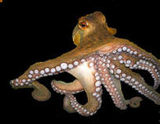 2. 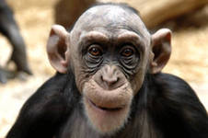 3. 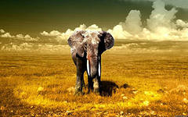 4. 5.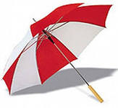 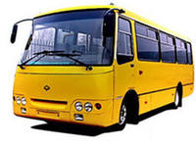
6. 7.
8.The letter after the letter R
9.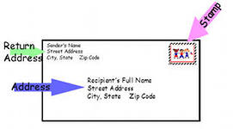 10. 11. 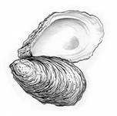
Answer: Columbus Day

Octopus, monkey, elephant, sun, umbrella, B, bus, S, address, car, oyster.
- Reading a text. (5’)
- Say a few sentences about Columbus. (3’)
- Speaking (working in groups): (5’)
Imagine that you were explorers and you have to choose only five things which are more useful and important for you:
compass, tools, water, food, money, fishing net, books, tobacco, musical instruments, money, camera, chocolate, matches, hat, sun glasses, phone, computer,
Begin a sentence: If we were explorers, we would take ….
Pupils work in groups. Then one pupil from each group answers proves their choice.
- Doing a test on the text “Columbus Day” (15’)
- Self-evaluation of the test (2’)
- Making a conclusion (1’)
Teacher: Now I want you to answer the last question.
What have you learned today? Can you answer it?
Homework: Write a composition: “If you were a famous explorer, what would you explore?”

Keys to the test “Columbus Day”:
- The second Monday of October
- New York
- The coming of Columbus’s ship to America
- 1492
- Italian-Americans and Hispanic-Americans
- Italy
- Spain
- New York
- Franklin Roosevelt
- Flat
- Round
- the Santa Maria, the Nina and the Pinta
- reached
- the New World
- took place
- In his honour
- For, after
- Lay
- Closer
- Has been

