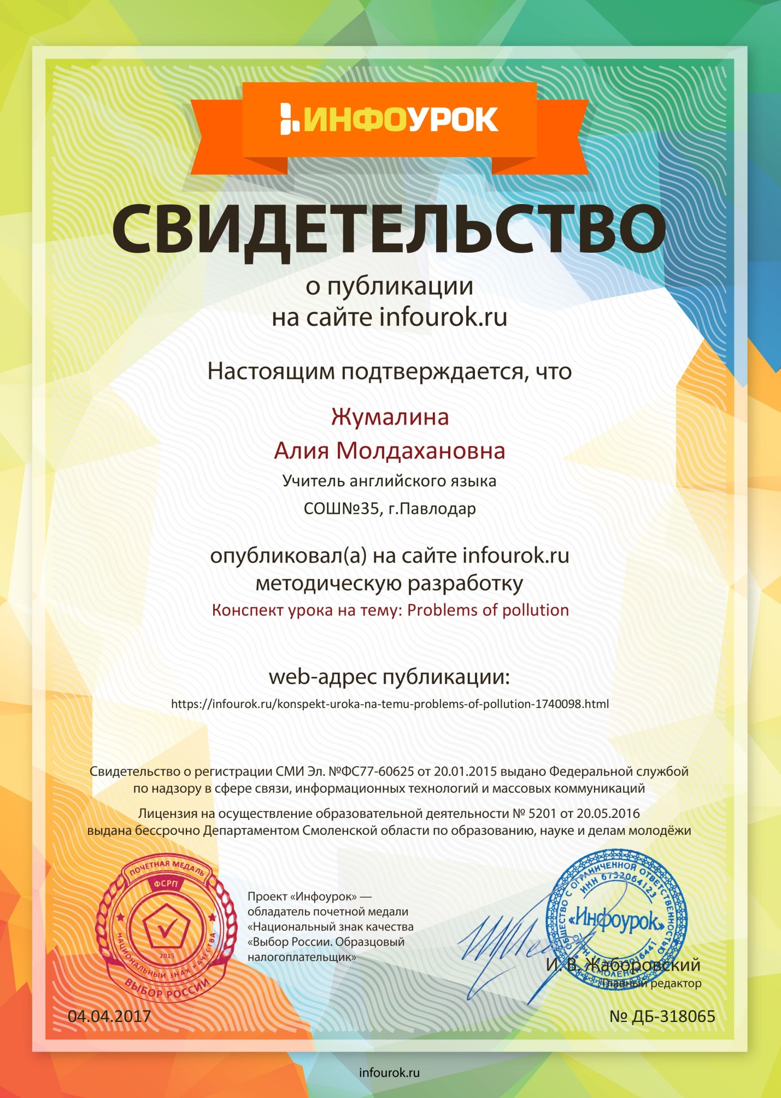

Pollution of environment and the ways of solving them.
Grade: 9 «Ә»

1. Greeting.
Hello. Nice to see you again.
- How are you?
- What’s the weather like?
- Do you like it?
- Do you like our nature?
- Does it have any problems?
You know, we have real problems with our environment. Today we’ll speak about The Pollution of Environment and the ways of solving it. So, what is pollution for you?

2. Words and their meanings (pair work)
It’s very important to understand the meaning of some words. So, read the meaning and guess the word. Work in groups of two. (cards with the words and their meanings, slide)

3. Homework (all group work)
Your hometask was to prepare a presentation about the problems of Pollution and make some questions about it. Who wants to show it? Let’s watch the presentations and answer the questions. (presentation)

4. Work with the poster (work in groups)
What words are connected with the water and air pollution?
Divide into two groups , look at the poster, divide the phrases into the next categories and put them in the correct place. 1 group work with the word “AIR” and another with “WATER”. (poster on the board and cards)

5. Situation. (all group work)
I’ve visited the foreign conference about the Environmental Problems and the ways of solving them. Read my report about it and underline the answers to the questions. (slide, texts, questions)

6. Complete the table. (individual work, all group work)
How can we help our planet?
In order to understand all the situation with our ecology it’s necessary to complete the table. Do it individually. (tables). .. Let’s check it up together (slide)

7. Discussion (all group work)
Look at the board. You see two flowers without petals. The first flower-the problems in environment, the second flower- the solutions.(poster with two flowers without petals on it, petals with problems, petals with solutions)

8. Conclusion (all group work)
What can we do to keep the Earth clean and healthy?
What should be done to change the situation?
Lets complete the sentences…(slide)

9. Hometask and saying “Good bye”
Write a letter to future generations : Don’t pollute the Earth! (100-120 words)
Thank you for the lesson. See you.

Appendix 1
1.The scientific study of the natural relations of plants, animals, people.

Ecology.

2.The greatest problem of all modern cities

Pollution
3.A sort of fog with other substances mixed in i
Smog
4.It is polluted by traffic and smog from industrial enterprises
the air
5.They face the problem of preservation the environment
People
Appendix 3
POLLUTION
People have designed and produced up-to-date machines and technologies to make their life easier and more comfortable. But all these activities result in air and water pollution.
One of the most important problems is the oceans. A lot of ships crossing the oceans and seas, especially those that carry oil, put their wastes into water, and the water becomes dirty. As the result many birds and fish die because of polluted water, others are getting contaminated and people may get sick from eating them.
The second problem is air pollution. Cars and plants pollute the atmosphere with their wastes. They destroy the ozone layer which protects us from dangerous light of the Sun. They also destroy forests which are dying from acid rains.
Now people begin to realize the danger of their activity. People are concerned about the air and the water used by everyone; they are also concerned about the future of the planet because they understand that these activities affect the balance of nature.
In order to make our life not only easier but better and healthier we must protect the water, the air, the earth from pollution. Our planet belongs to our children and if we want to live in a healthier world we must do everything to protect them from the catastrophe.
QUESTIONS:
1. What is the result of people’s activities?
2. Do birds, animals and fish die because of polluted water?
3. What do wastes of cars and plants destroy?
4. What must we do if we want our children to live in a healthier world?
5. Do people get sick because of pollution? Why?
1. Use public transport because… (cars pollute the air),
2. Don’t put wastes into water….(water becomes dirty)
3. Use less washing up liquid because… (it pollutes the seas and rivers),
4. Protect the ozone layer/…(avoid spray cans)
5. Make our life healthier… (protect air and water)

