9 Grade
2 Tour
Speaking
Test 1
Monologue

Look at the pictures and tell a story. What happened? What did people do? Why? What did they feel?

Student A
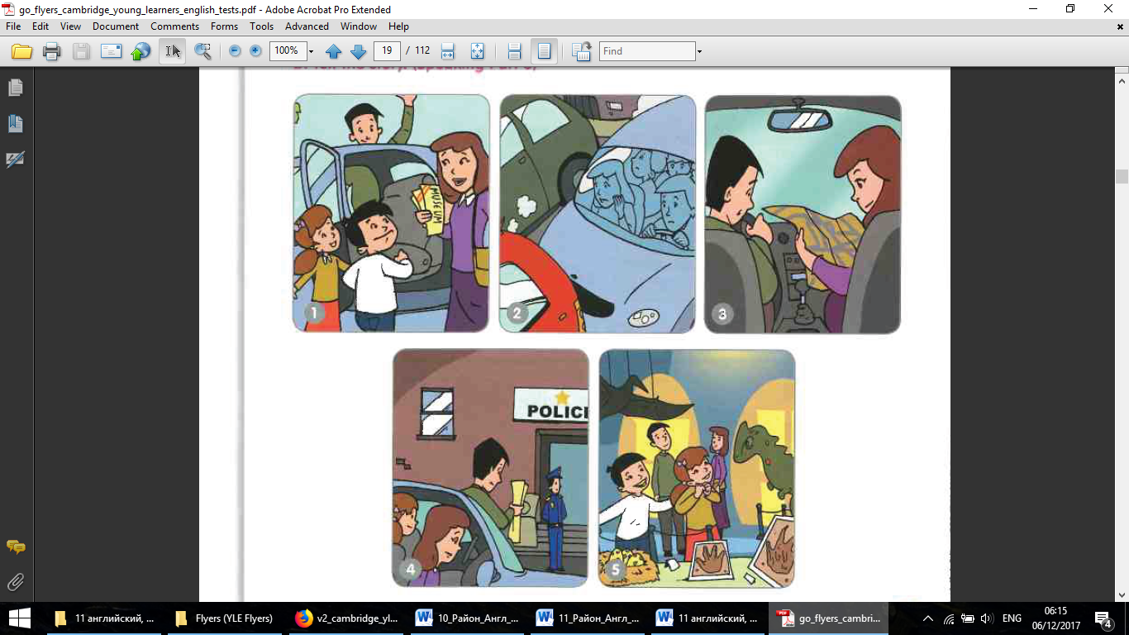

Student B
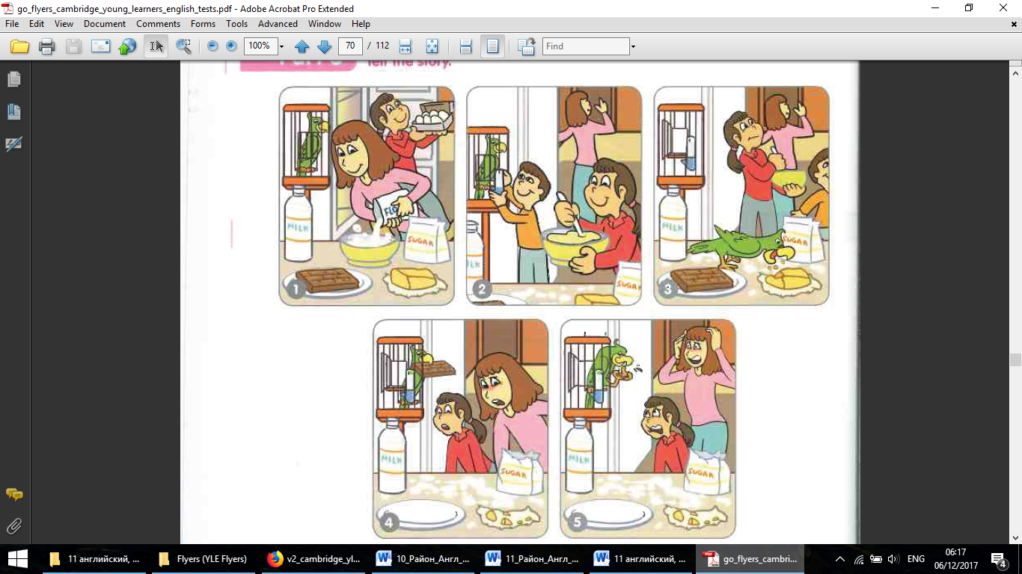

9 Grade
2 Tour
Speaking
Test 1
Dialogue

Discuss professions. What is the most dangerous? What is the most necessary or not necessary? What do you want to be in future?
Decide together which three professions are the most popular among teenagers.



9 Grade
2 Tour
Speaking
Test 2
Monologue

Look at the pictures and tell a story. What happened? What did people do? Why? What did they feel?

Student A
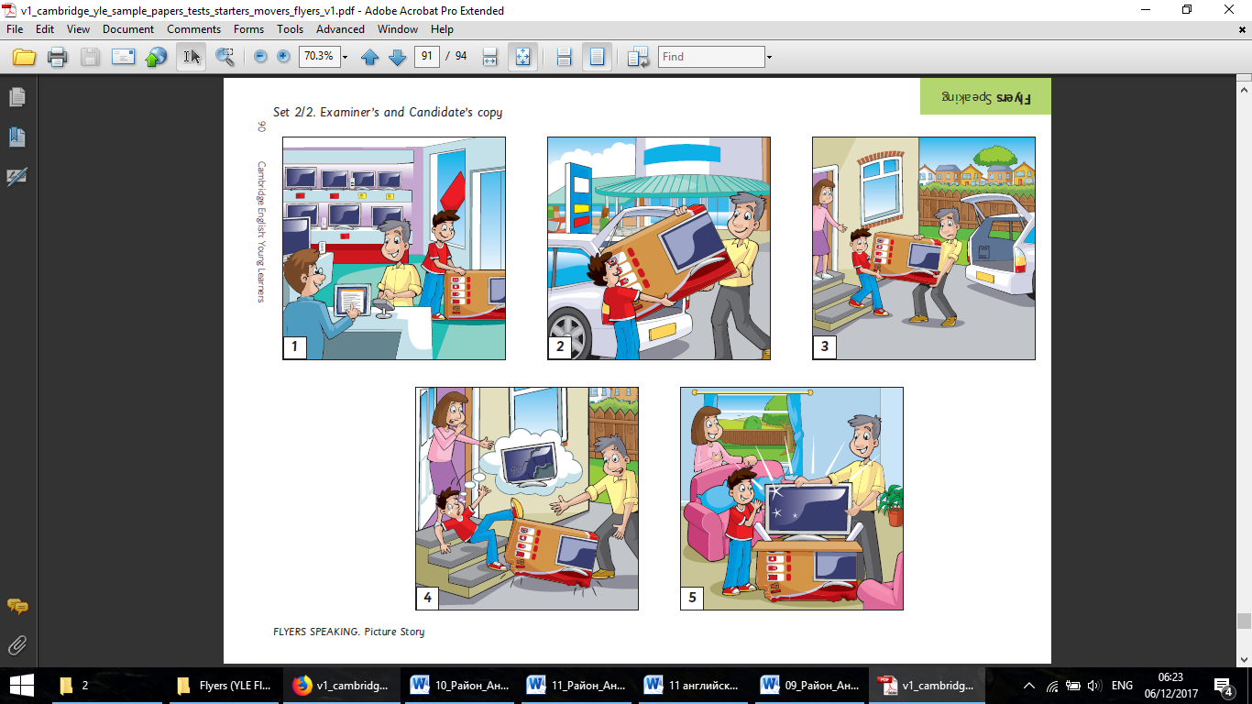

Student B
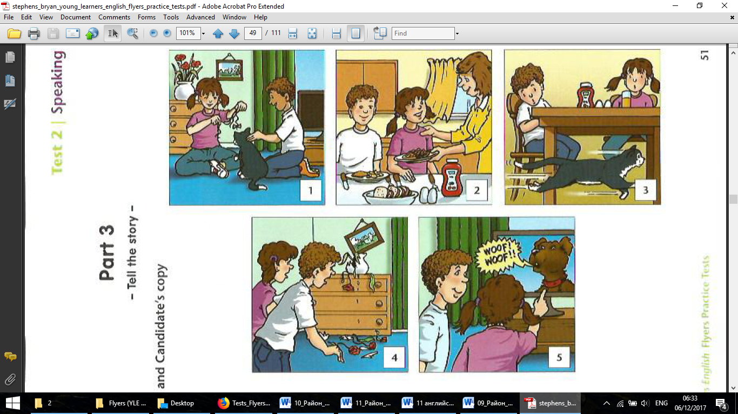

9 Grade
2 Tour
Speaking
Test 7
Dialogue

Discuss sports. Which sports are the most useful and less useful for teenagers’ health? Which sports are the most difficult and the easiest?
Decide which three sports are the most popular among teenagers in Kazakhstan.


9 Grade
2 Tour
Speaking
Test 3
Monologue

Look at the pictures and tell a story. What happened? What did people do? Why? What did they feel?

Student A
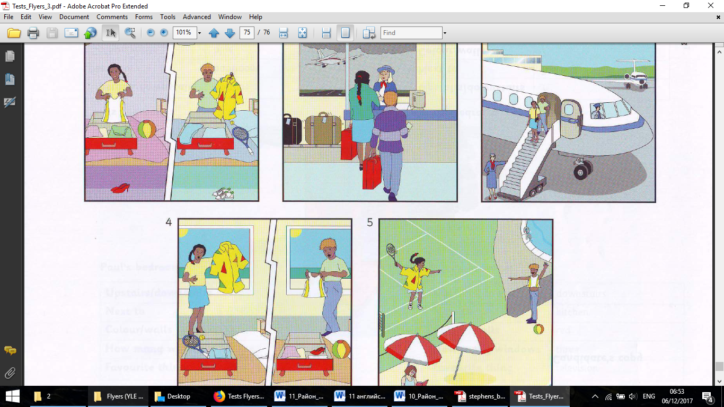

Student B
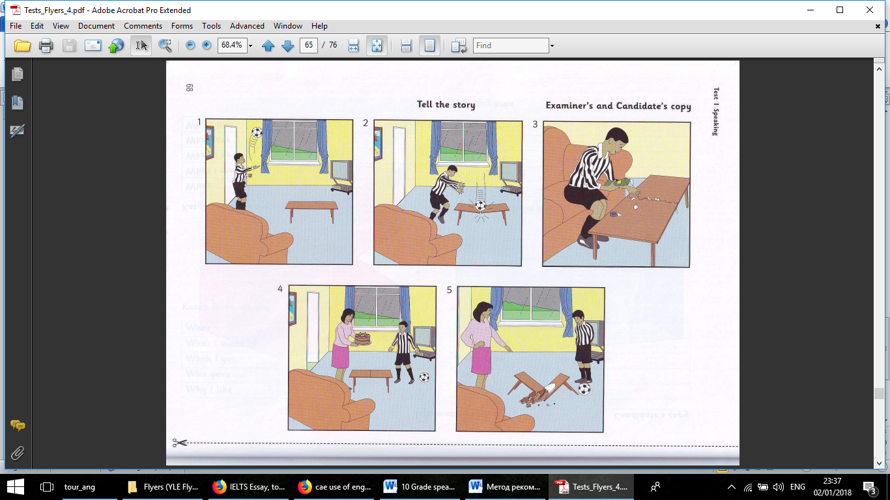

9 Grade
2 Tour
Speaking
Test 3
Dialogue

Discuss movie genres. What was the last movie you have watched? What is the most interesting genre? Why? What is the most necessary or not necessary?
Decide together which three genres are the most popular among teenagers.



9 Grade
2 Tour
Speaking
Test 4
Monologue

Look at the pictures and tell a story. What happened? What did people do? Why? What did they feel?

Student A
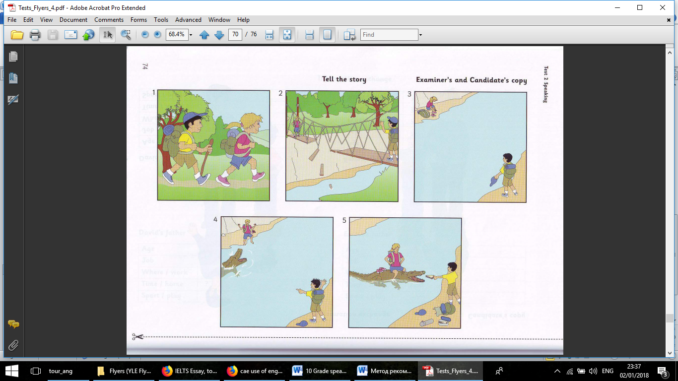
Student B

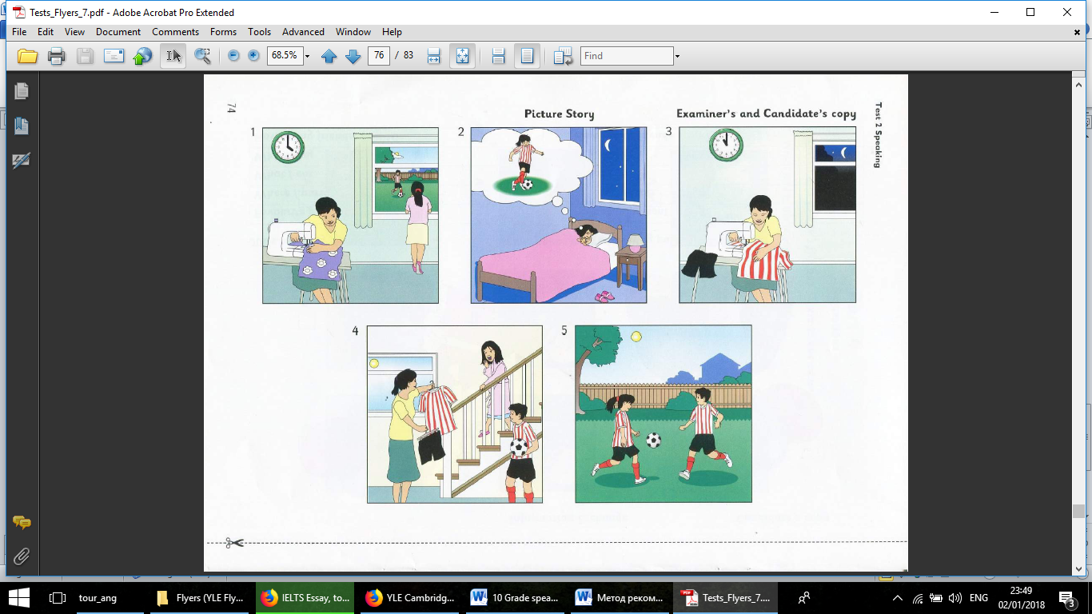
9 Grade
2 Tour
Speaking
Test 4
Dialogue

Discuss free time activities apart from the internet surfing. What are your current hobbies? What would you like to do if you had more time and money? Why? What is the most necessary or not necessary?
Decide together which three hobbies are the most popular among modern teenagers.



9 Grade
2 Tour
Speaking
Test 5
Monologue

Look at the pictures and tell a story. What happened? What did people do? Why? What did they feel?

Student A
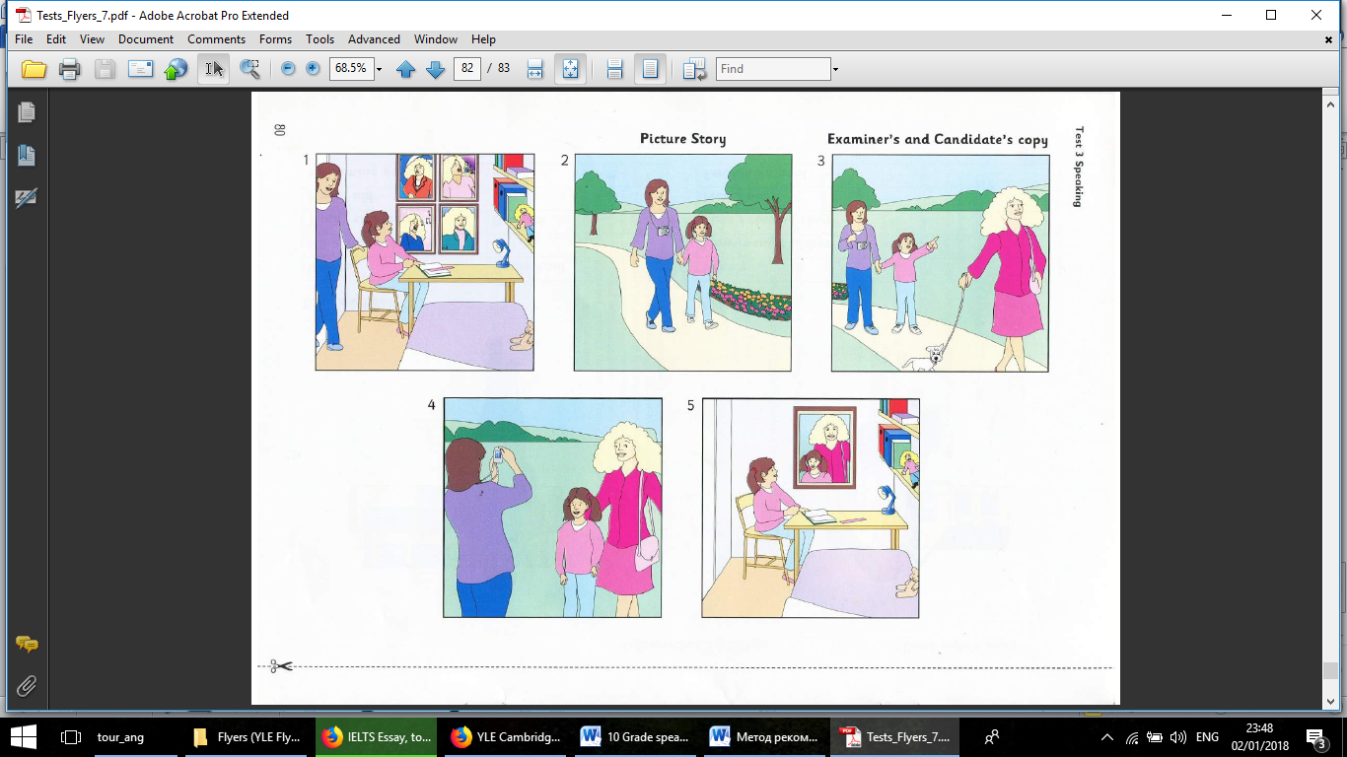

Student B
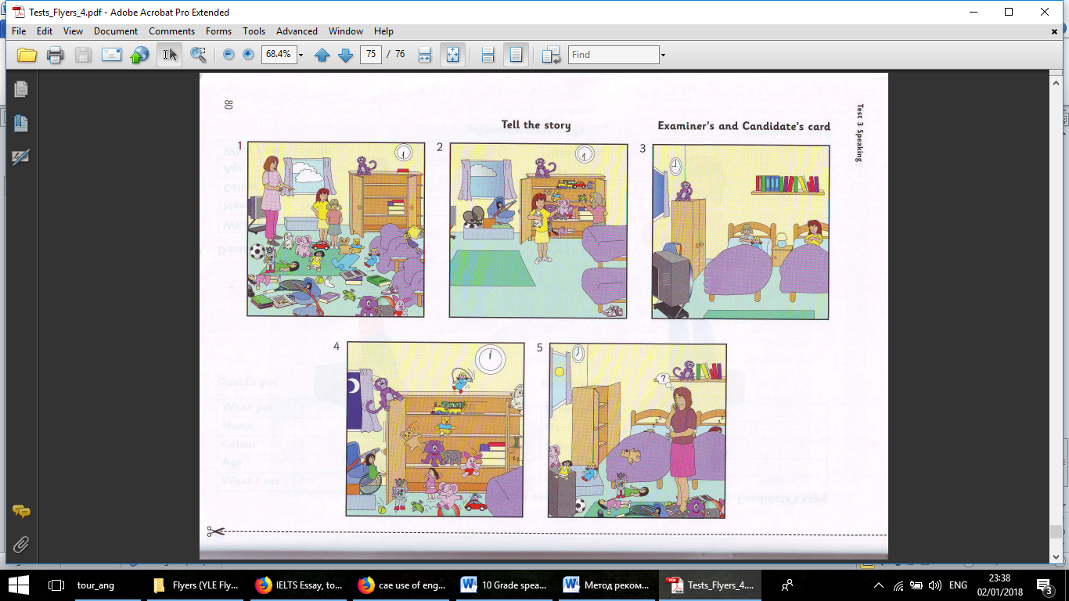

9 Grade
2 Tour
Speaking
Test 5
Dialogue

Discuss mass media and communication. What are the best ways to get news? What is the most useful or the least necessary?
Decide together which three means of communication are the most popular among modern teenagers.



9 Grade
2 Tour
Speaking
Test 6
Monologue

Look at the pictures and tell a story. What happened? What did people do? Why? What did they feel?

Student A
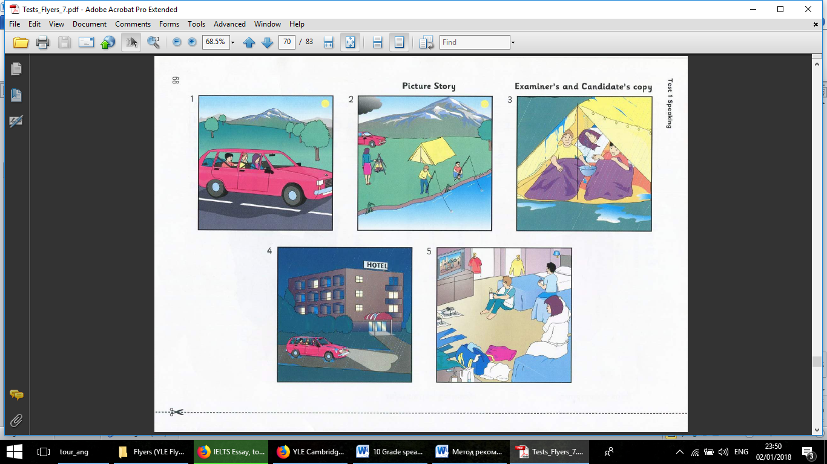
Student B
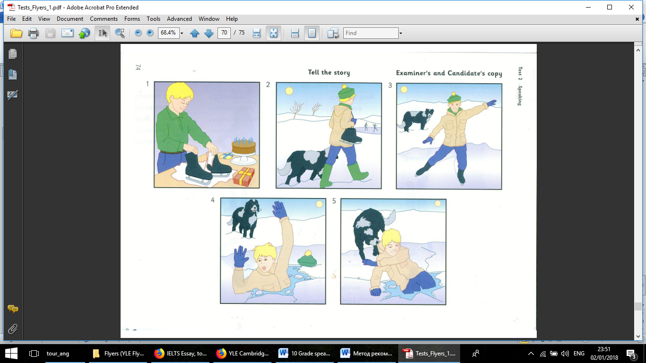

9 Grade
2 Tour
Speaking
Test 6
Dialogue

Discuss science and technology. What is the most necessary fields of study nowadays? Which fields are the most developed in your country?
Decide together which three fields are the most popular among modern teenagers.


9 Grade
2 Tour
Speaking
Test 7
Monologue

Look at the pictures and tell a story. What happened? What did people do? Why? What did they feel?

Student A
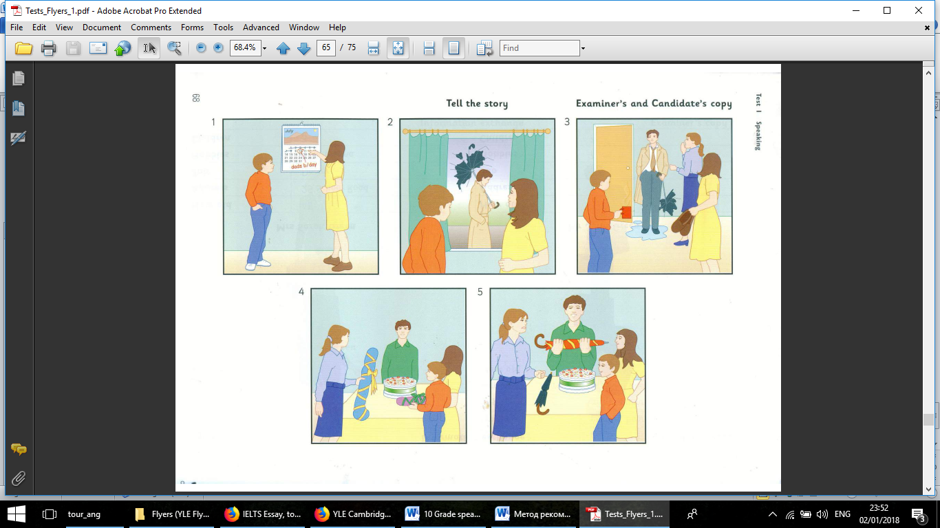
Student B
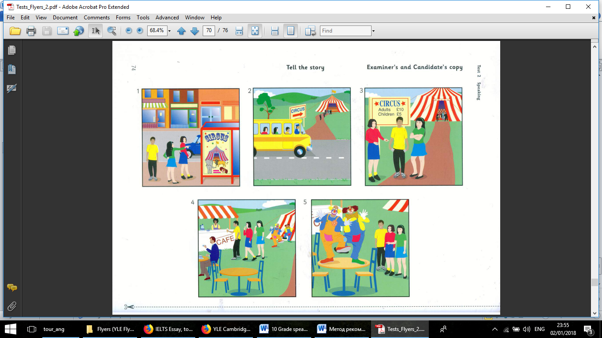

9 Grade
2 Tour
Speaking
Test 7
Dialogue

Discuss the bad sides of the internet. What are the possible cyber dangers of the Internet? What are the ways to avoid being a victim of a cybercrime?
Decide together which three internet crimes are the most dangerous among teenagers. Why?



10 Grade
2 Tour
Speaking
Test 1
Monologue

Learning about the past has no value for those of us living in the present. Do you agree or disagree? Use specific reasons and examples to support your opinion.

________________________________________________________________________

10 Grade
2 Tour
Speaking
Test 2
Monologue
People attend college or university for many different reasons (for example, new experiences, career preparation, or to increase knowledge). Why do you think people attend college or university in your country? Use specific reasons and examples to support your opinion.
________________________________________________________________________

10 Grade
2 Tour
Speaking
Test 3
Monologue

The best way to reduce the number of traffic accidents is to increase fines for drivers and to tighten up the licencing rules. To what extent do you agree or disagree with this opinion? Use specific reasons and examples to support your opinion.

________________________________________________________________________

10 Grade
2 Tour
Speaking
Test 4
Monologue

Millions of people every year move to English- speaking countries such as Australia, Britain or America, in order to study at school, college or university. Why do so many people want to study in English? Why is English such an important international language?

________________________________________________________________________

10 Grade
2 Tour
Speaking
Test 5
Monologue

You can get up-to-date news from the radio, TV and the Internet. What are the advantages and disadvantages of each type of media? Use specific reasons and examples to support your opinion.

________________________________________________________________________

10 Grade
2 Tour
Speaking
Test 6
Monologue

Every year an increasing number of students choose to go to another country for their higher education. Do you think the benefits of this development outweigh the problems associated with it?

________________________________________________________________________

10 Grade
2 Tour
Speaking
Test 7
Monologue

Some people prefer to spend their lives doing the same things and avoiding changes. Others, however think that change is always a good thing. Discuss both sides and give your own opinion.

________________________________________________________________________

10 Grade
2 Tour
Speaking
Test 8
Monologue

Modern children are suffering from the diseases that were once considered to be meant for adults only. Obesity is a major disease prevalent among children. What are its causes and what solutions can be offered?

________________________________________________________________________

10 Grade
2 Tour
Speaking
Test 9
Monologue

Some people think that spending a lot on holding wedding parties, birthday parties and other celebrations is just a waste of money. Others, however, think that these are necessary for individuals and the society. Discuss both views and give your opinion.

________________________________________________________________________

10 Grade
2 Tour
Speaking
Test 10
Monologue
Some people say that the Internet is making the world smaller by bringing people together. To what extent do you agree that the internet is making it easier for people to communicate with one another?
________________________________________________________________________

10 Grade
2 Tour
Speaking
Test 1
Dialogue

___________________________________________________________________

10 Grade
2 Tour
Speaking
Test 2
Dialogue

___________________________________________________________________

10 Grade
2 Tour
Speaking
Test 3
Dialogue

___________________________________________________________________

10 Grade
2 Tour
Speaking
Test 4
Dialogue

___________________________________________________________________
10 Grade
2 Tour
Speaking
Test 5
Dialogue

___________________________________________________________________
10 Grade
2 Tour
Speaking
Test 6
Dialogue

___________________________________________________________________

10 Grade
2 Tour
Speaking
Test 7
Dialogue

___________________________________________________________________
10 Grade
2 Tour
Speaking
Test 8
Dialogue

___________________________________________________________________

10 Grade
2 Tour
Speaking
Test 9
Dialogue

___________________________________________________________________
10 Grade
2 Tour
Speaking
Test 10
Dialogue

___________________________________________________________________

11 Grade
2 Tour
Speaking
Test 1
Monologue
Students from rural areas often find it difficult to access university education. Some people think that it should become easier for them to study at universities. To what extent do you agree or disagree with this opinion?
________________________________________________________________________

11 Grade
2 Tour
Speaking
Test 2
Monologue

In many countries children are engaged in different kinds of paid work. Some people regard this as completely wrong, while others consider it a valuable work experience, important for learning and taking responsibility. What is your opinion?

________________________________________________________________________

11 Grade
2 Tour
Speaking
Test 3
Monologue
Full time university students spend most of the time studying. They should be doing other activities too. To what extent do you agree or disagree?
________________________________________________________________________

11 Grade
2 Tour
Speaking
Test 4
Monologue

Some people think that schools should select students according to their academic abilities, while others believe that it is better to have students with different abilities studying together. Discuss both views and state your own opinion.

________________________________________________________________________

11 Grade
2 Tour
Speaking
Test 5
Monologue

Many adolescent offenders commit more crimes after serving the first punishment. Why is this happening, and what measures can be taken to tackle this problem?

________________________________________________________________________

11 Grade
2 Tour
Speaking
Test 6
Monologue

When a country develops its technology, the traditional skills and ways of life die out. It is pointless to try and keep them alive. To what extent do you agree or disagree with this opinion?

________________________________________________________________________

11 Grade
2 Tour
Speaking
Test 7
Monologue

Schools should allocate the same amount of money to their sport activities as they allocate to their libraries. To what extent do you agree or disagree with this opinion?

________________________________________________________________________

11 Grade
2 Tour
Speaking
Test 8
Monologue

Some people say education is the only critical factor to the development of a country. To what extent do you agree or disagree with this statement?

________________________________________________________________________

11 Grade
2 Tour
Speaking
Test 9
Monologue

Some people think that it is important to use leisure time for activities that develop the mind, such as reading and doing crossword puzzles. Others feel that it is important to give one’s mind a rest in leisure time. Discuss both views and give your opinion.

________________________________________________________________________

11 Grade
2 Tour
Speaking
Test 10
Monologue

The world is experiencing a dramatic increase in population, which is causing problems not only for poor, undeveloped countries, but also for industrialized and developed nations. Describe some of the problems that overpopulation causes, and suggest at least one possible solution.

________________________________________________________________________

11 Grade
2 Tour
Speaking
Test 1
Dialogue

____________________________________________________________________

11 Grade
2 Tour
Speaking
Test 2
Dialogue____________________________________________________________________

11 Grade
2 Tour
Speaking
Test 3
Dialogue

___________________________________________________________________
_
11 Grade
2 Tour
Speaking
Test 4
Dialogue

___________________________________________________________________
11 Grade
2 Tour
Speaking
Test 5
Dialogue

___________________________________________________________________

11 Grade
2 Tour
Speaking
Test 6
Dialogue

___________________________________________________________________

11 Grade
2 Tour
Speaking
Test 7
Dialogue

___________________________________________________________________

11 Grade
2 Tour
Speaking
Test 8
Dialogue

___________________________________________________________________

11 Grade
2 Tour
Speaking
Test 9
Dialogue

___________________________________________________________________

11 Grade
2 Tour
Speaking
Test 10
Dialogue

